Virtualized Penetration Testing Environment Setup
Course Title: ITC 4610 Penetration Testing
Professor Betty J. Lauer
Mandip Amgain
January 28, 2026

Introduction
This project involved designing and implementing a virtualized penetration testing environment to safely practice security assessment techniques. The lab simulates an enterprise network using multiple operating systems connected through an isolated internal network.

Virtualization Platform
Oracle VirtualBox was selected as the hypervisor because it is free, stable, and beginner friendly. It supports both ISO-based installations and preconfigured virtual machines, making it ideal for building a penetration testing lab.

Network Configuration
All virtual machines were connected to a VirtualBox internal network named Pentest_Internal_Net using the private IP range 100.64.0.0/24. The internal network prevents internet exposure while allowing full communication between lab systems.
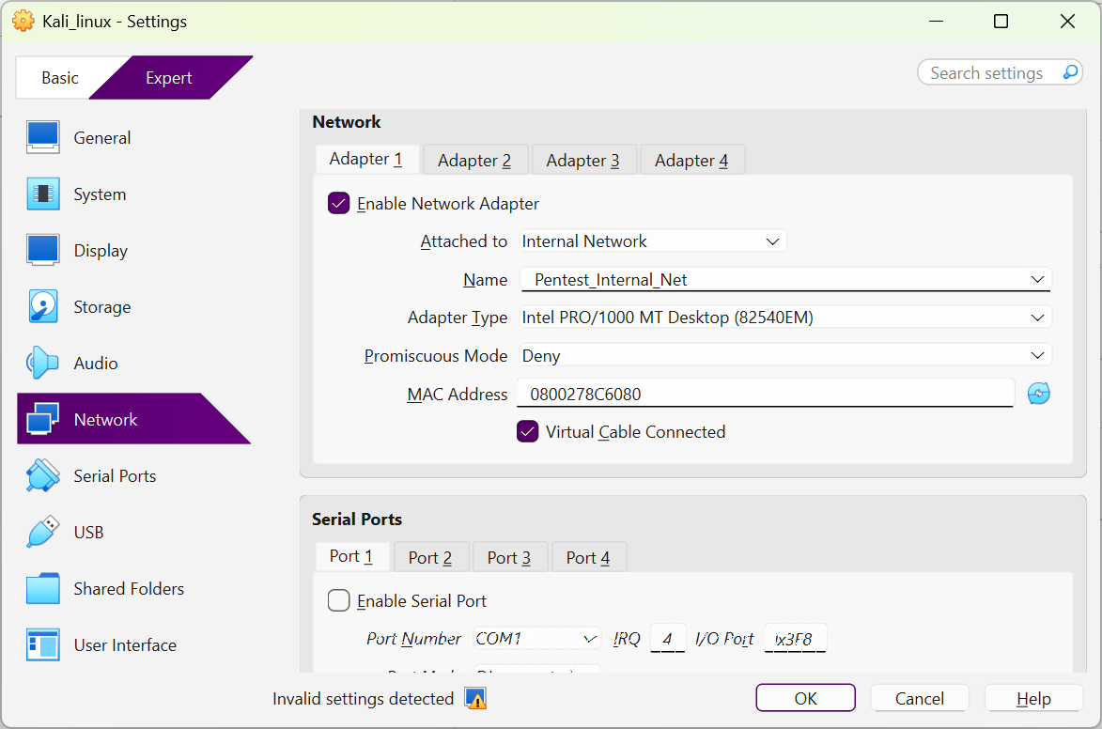
Figure 1. Kali Linux VirtualBox network adapter configuration showing Adapter 1 attached to the internal network Pentest_Internal_Net.
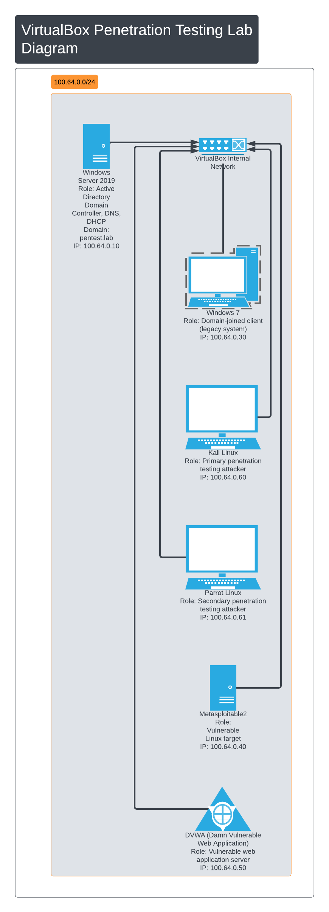
Figure 2. Illustrates the internal network architecture of the penetration testing lab, including IP addressing, operating system roles, and system connectivity.
Virtual Machines and Roles
- Windows Server 2019 was configured as a domain controller providing Active Directory, DNS, and DHCP services for the network.
- Windows 7 functioned as a domain-joined client system, representing a legacy endpoint.
- Kali Linux and Parrot Linux were used as attacker machines for penetration testing activities.
- Metasploitable2 and DVWA served as intentionally vulnerable targets for exploitation and web-application testing.
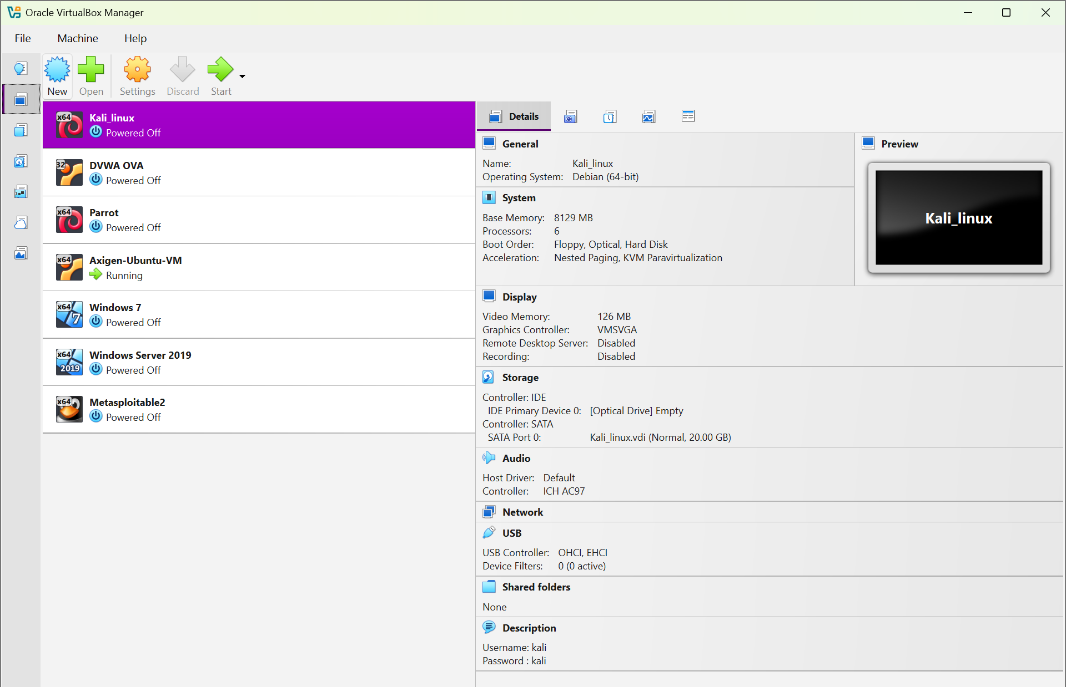
Figure 3. Oracle VirtualBox Manager displaying the configured virtual machines used in the penetration testing lab environment.
Testing and Validation
Basic functionality was verified by confirming system boot, IP address assignment via DHCP, and network connectivity. Kali Linux successfully communicated with all targets, confirming correct configuration.

Conclusion
This virtual lab provides a controlled environment for learning penetration testing techniques while maintaining safety and isolation. The design mirrors real-world enterprise networks and supports future security testing exercises.

